**BG View Page**

When you open this page. Below image will show for few second the drag you to saguaro national park.

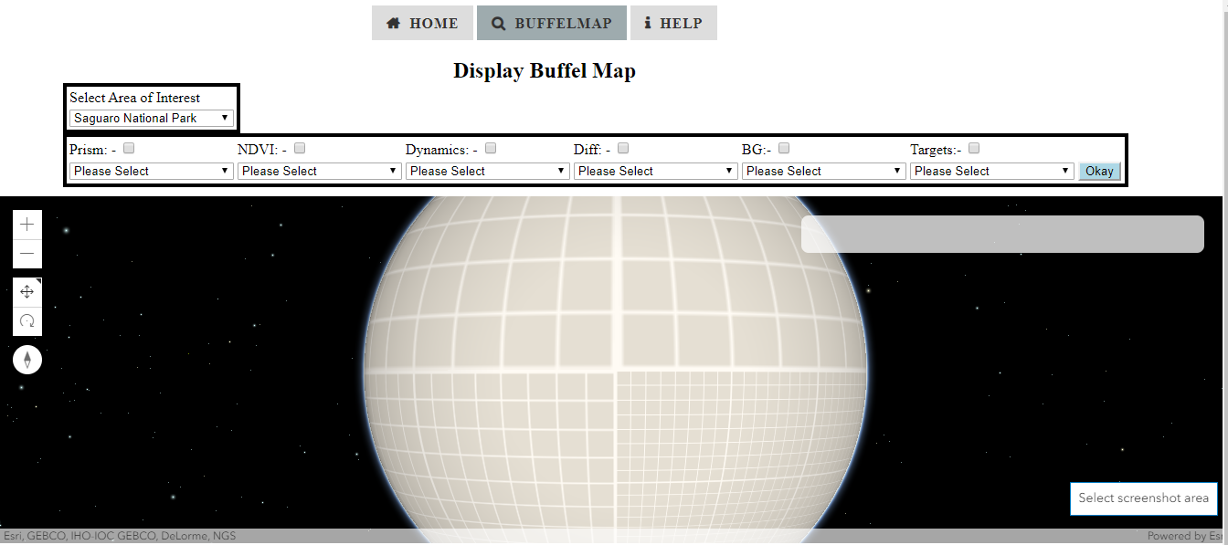

Figure 1 First Look of BG View page

It will Automatically Show Saguaro National Park

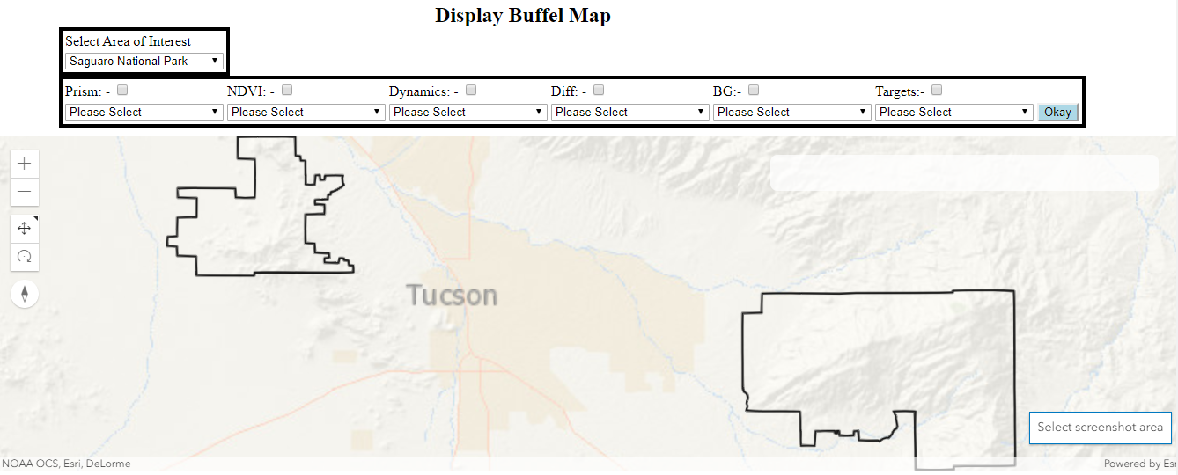

Figure 2 Automatically drag to saguaro national park

User Option to select area of interest. Or by default is Saguaro national Park. Next step. You can Select checkbox and select layer you want to display on the map and press okay.

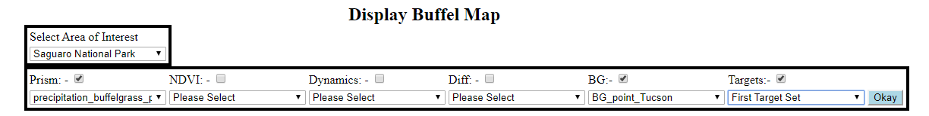

Figure 3 Selection Field to display on map.

After pressing Okay. The layers will be display on map.

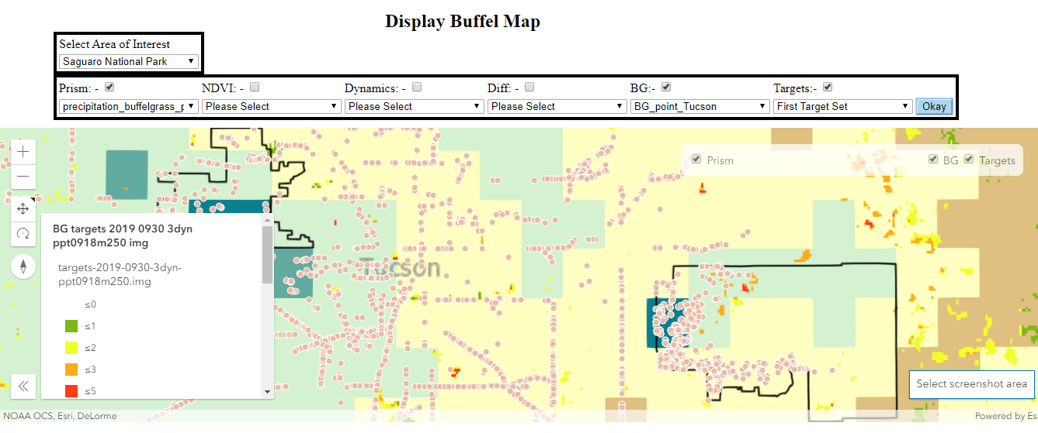

Figure 4 Display layers on the map

If you can want to clip area and save to your computer. Click on select area.

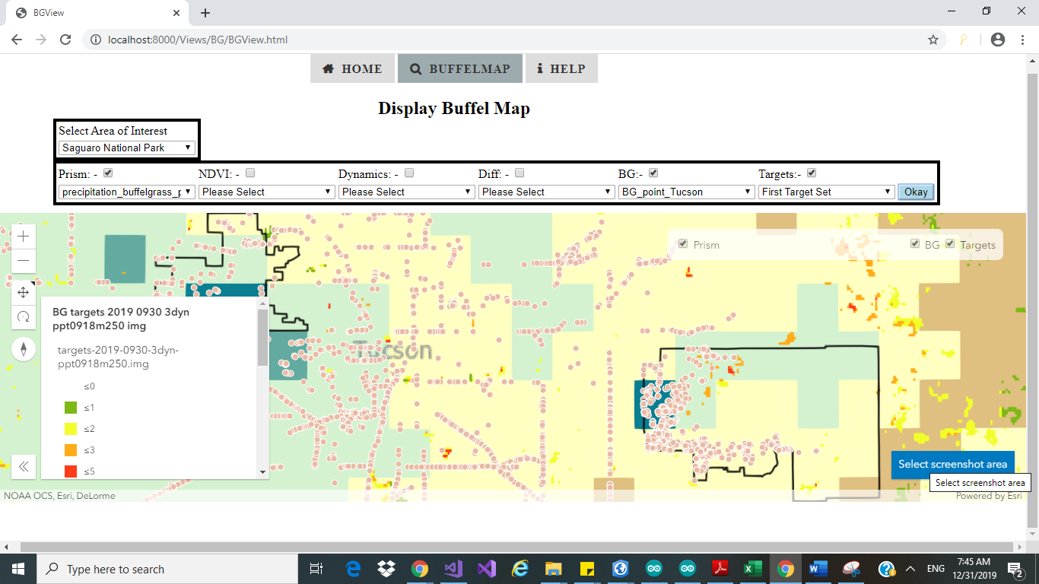

Figure 5 Image to show Select Screenshot area

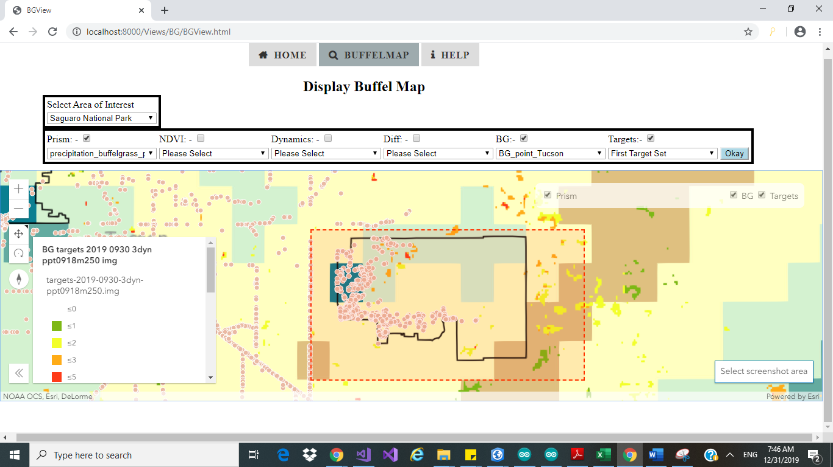

Figure 6 Select area you want to clip

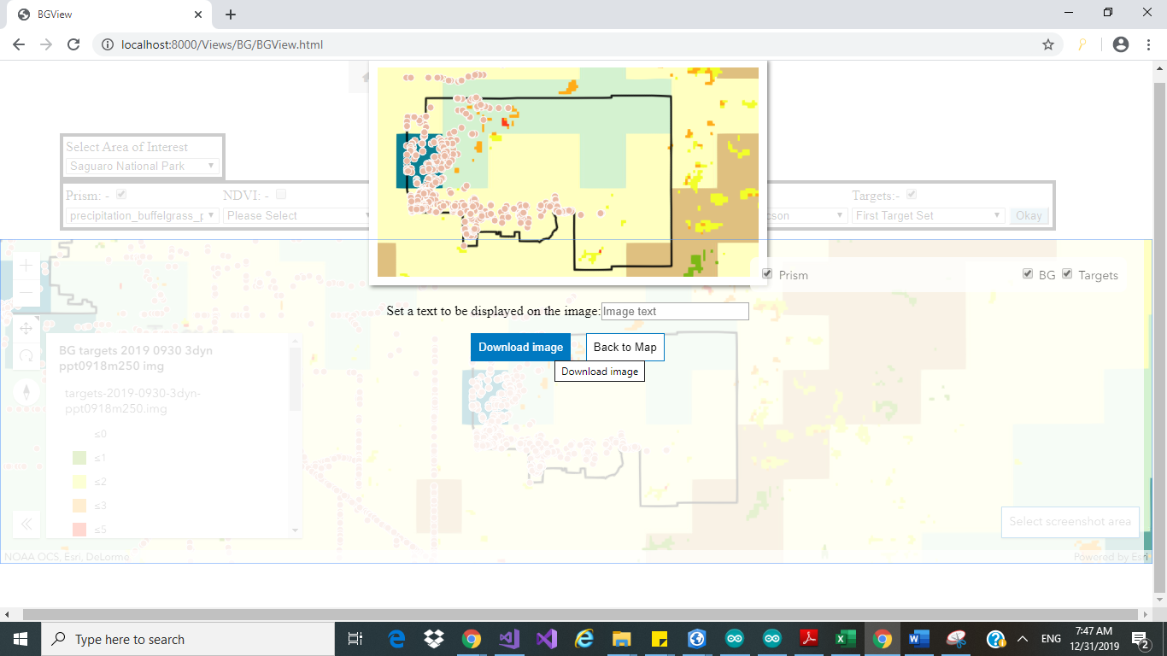

Figure 7 Click to download or type text to save as